CHAPTER-4

RESULTS

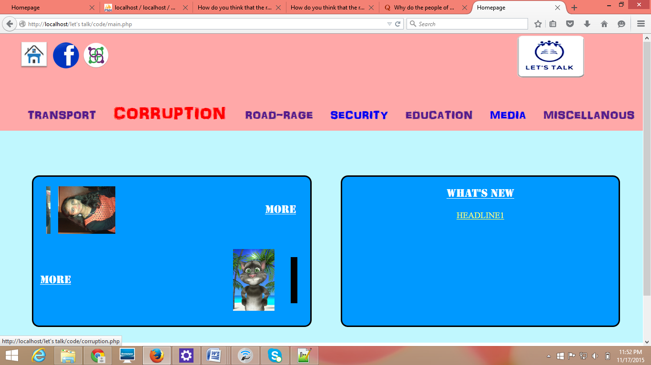

Fig. 4.1: Home page

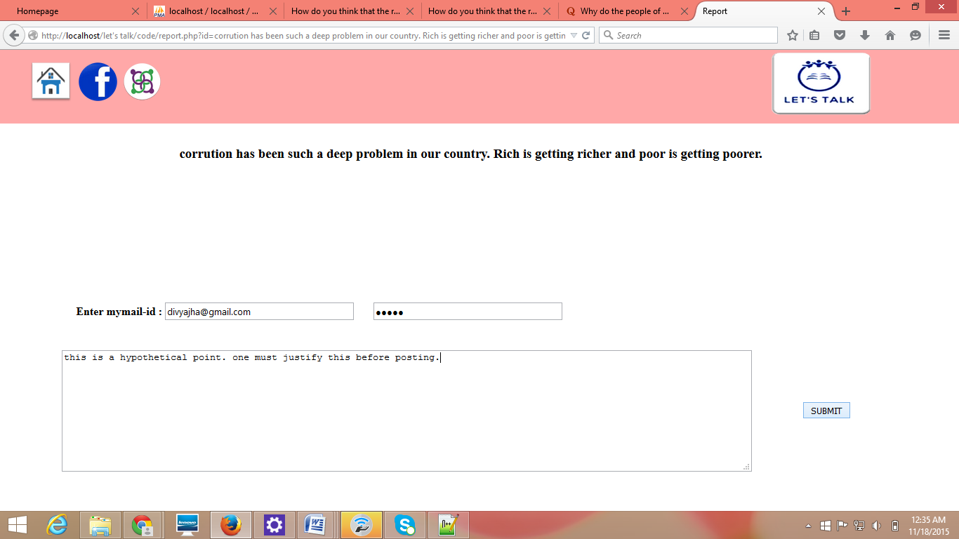

Fig. 4.2: Report an objection on the post

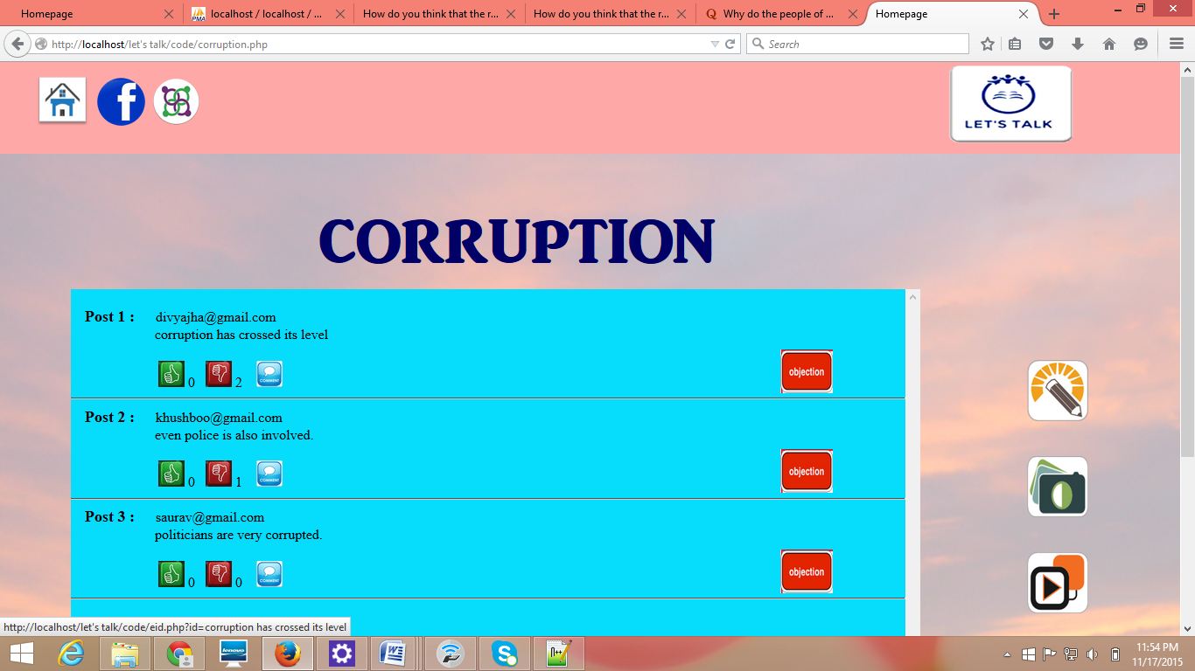

Fig. 4.3: Category

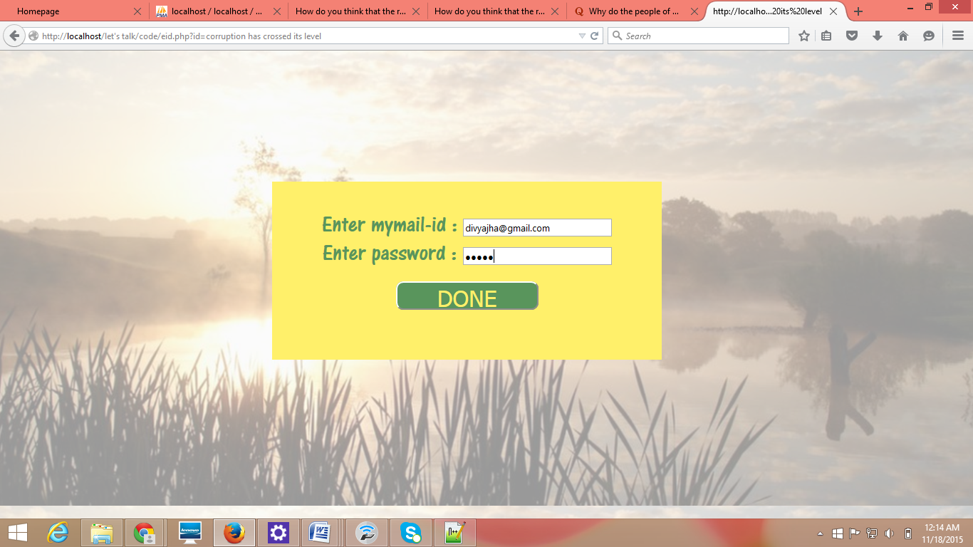  
Fig. 4.4: Verification of mail-id

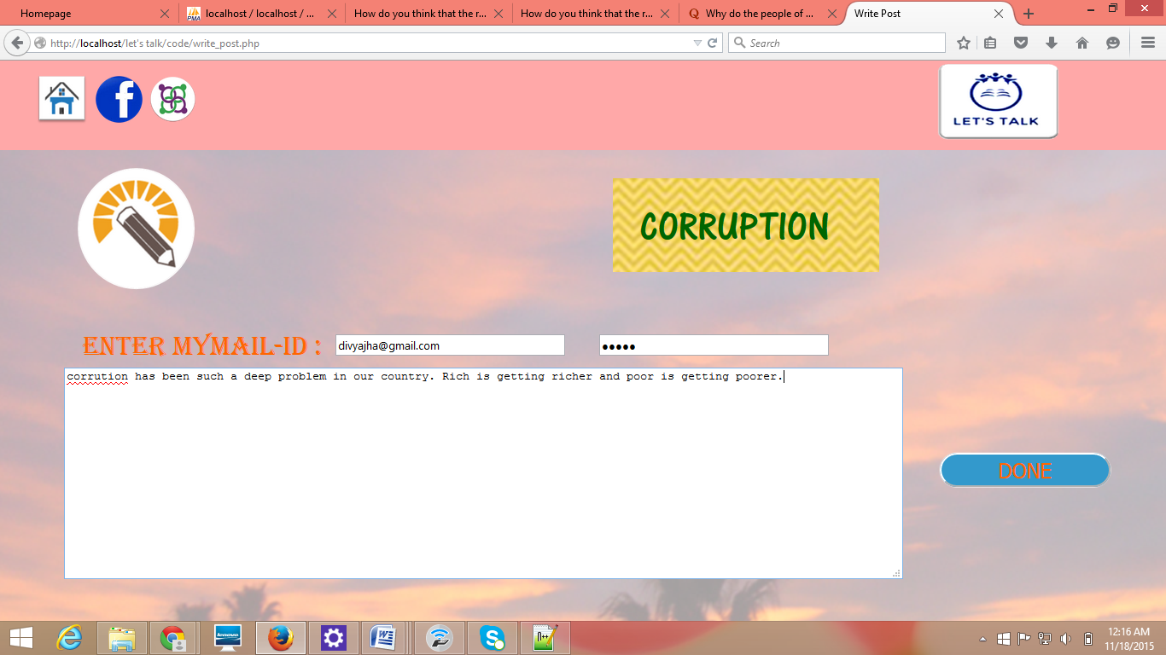

Fig. 4.5: Writing section

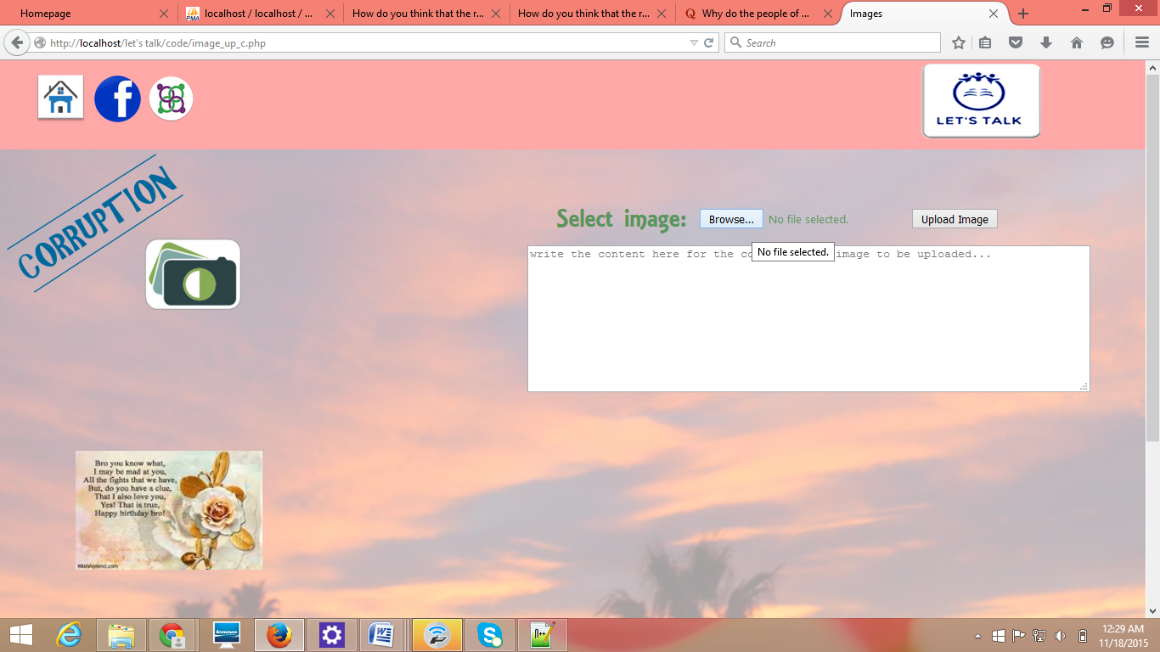

Fig. 4.6: Image upload

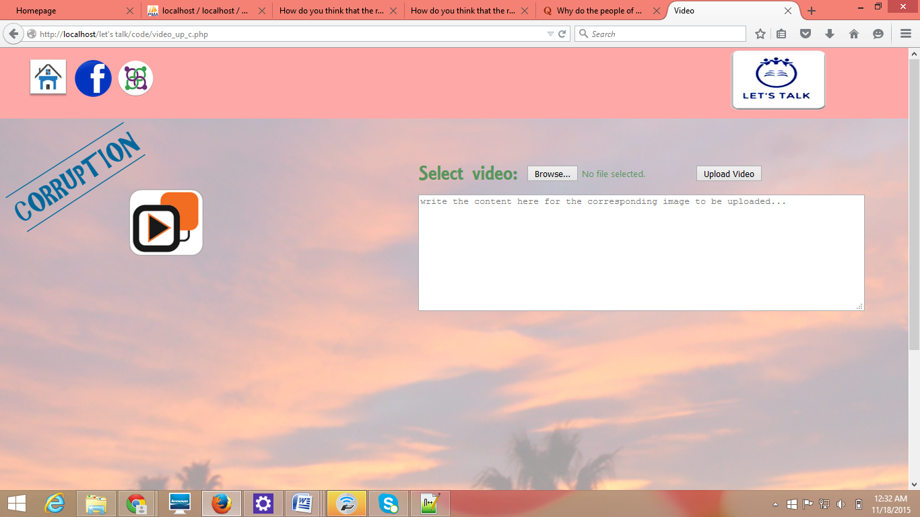

Fig. 4.7: Video upload

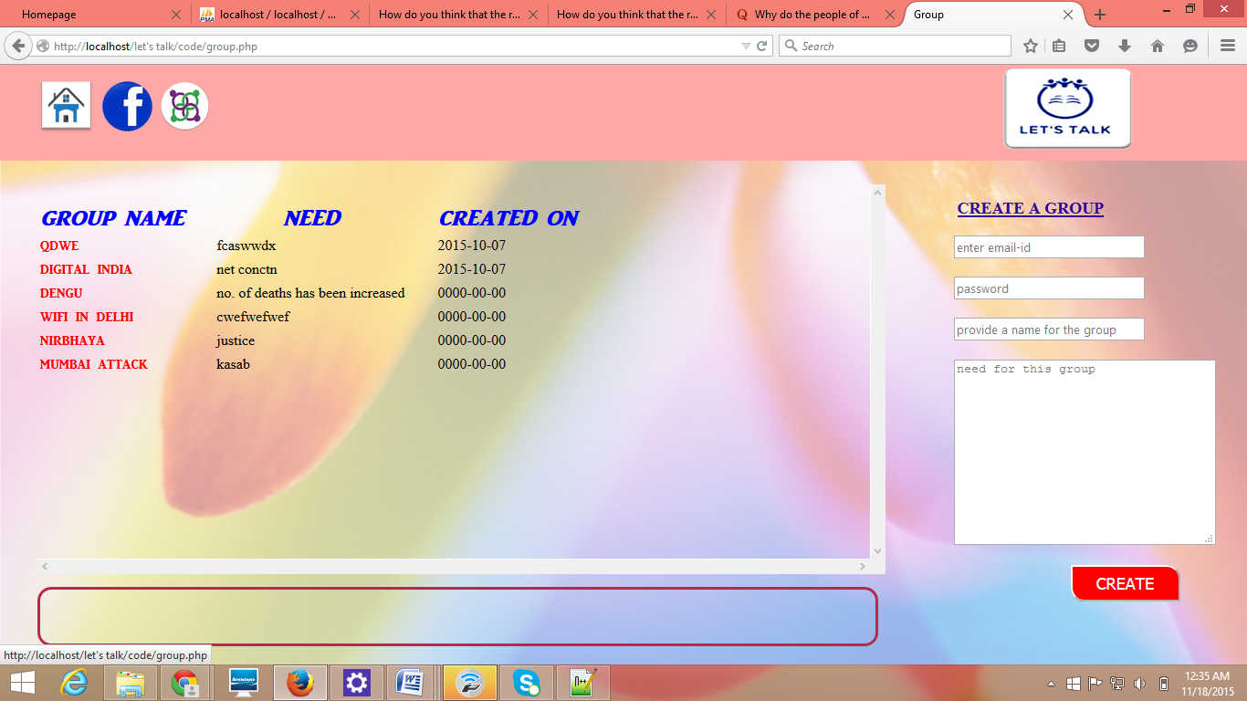

Fig. 4.8: View of groups

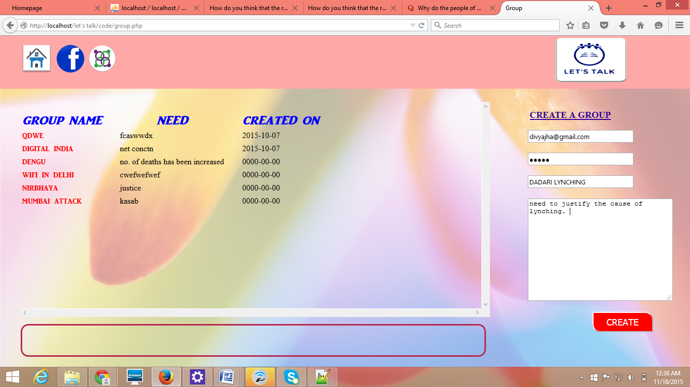

Fig. 4.9: Formation of groups

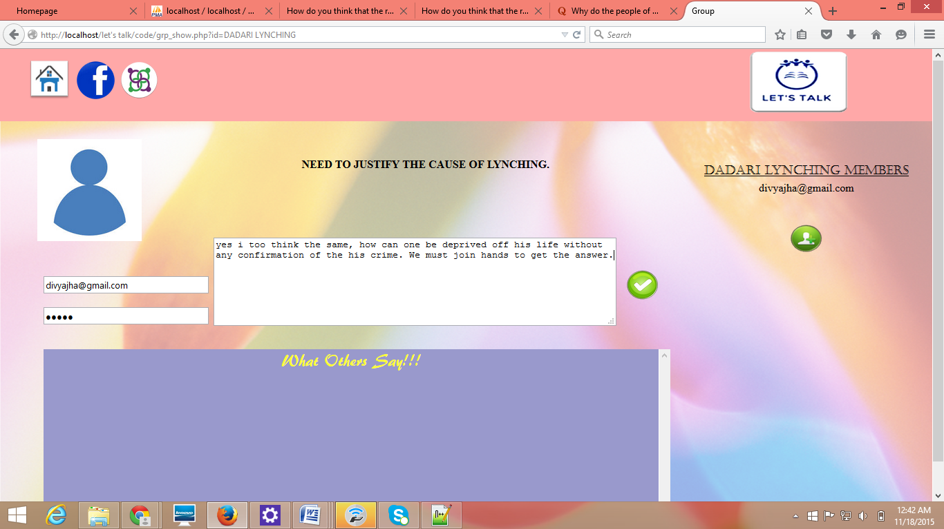

Fig. 4.10: Participation in group

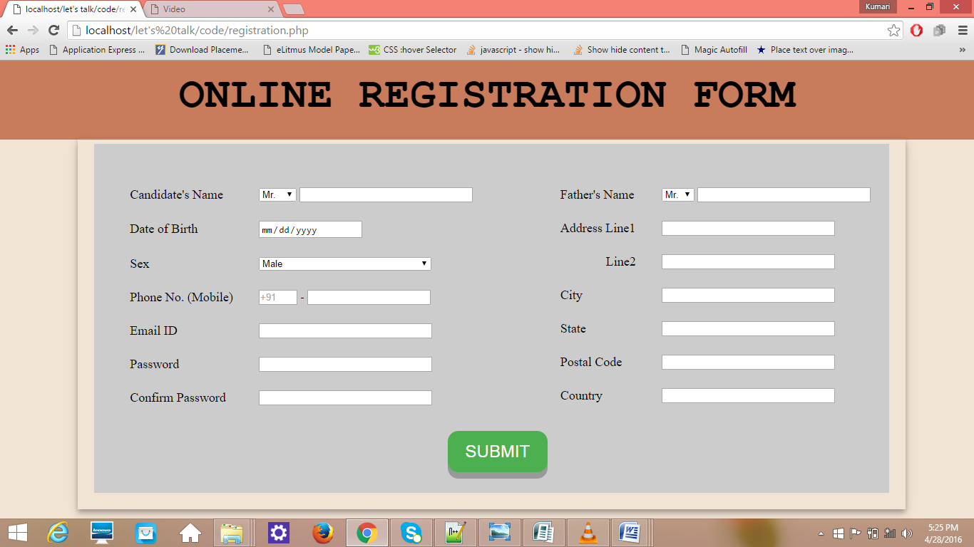

Fig. 4.11: Registration

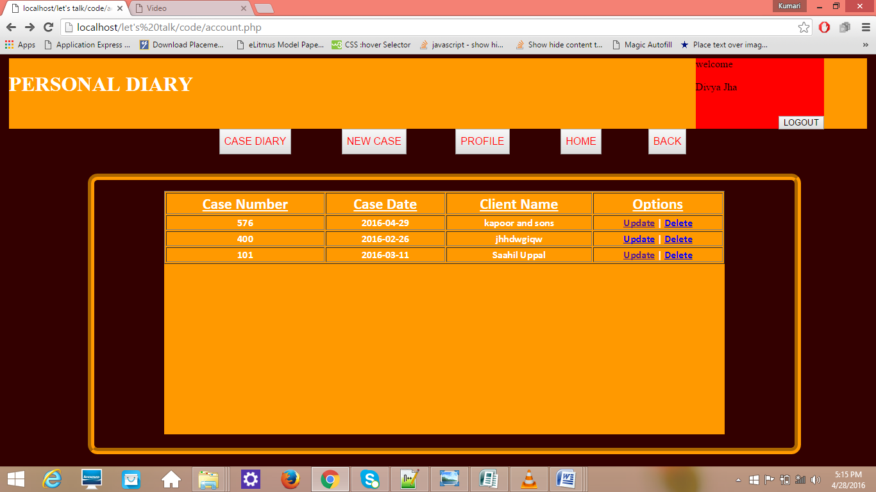

Fig. 4.12: Case diary

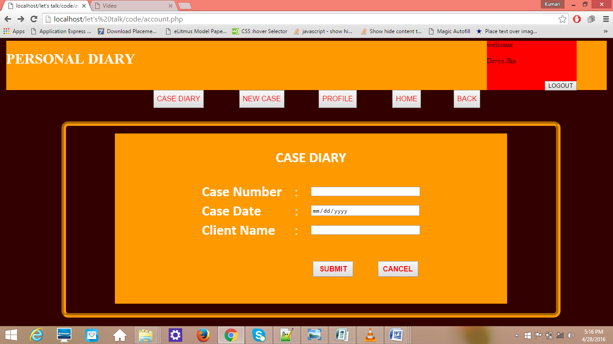

Fig. 4.13: Creating new case

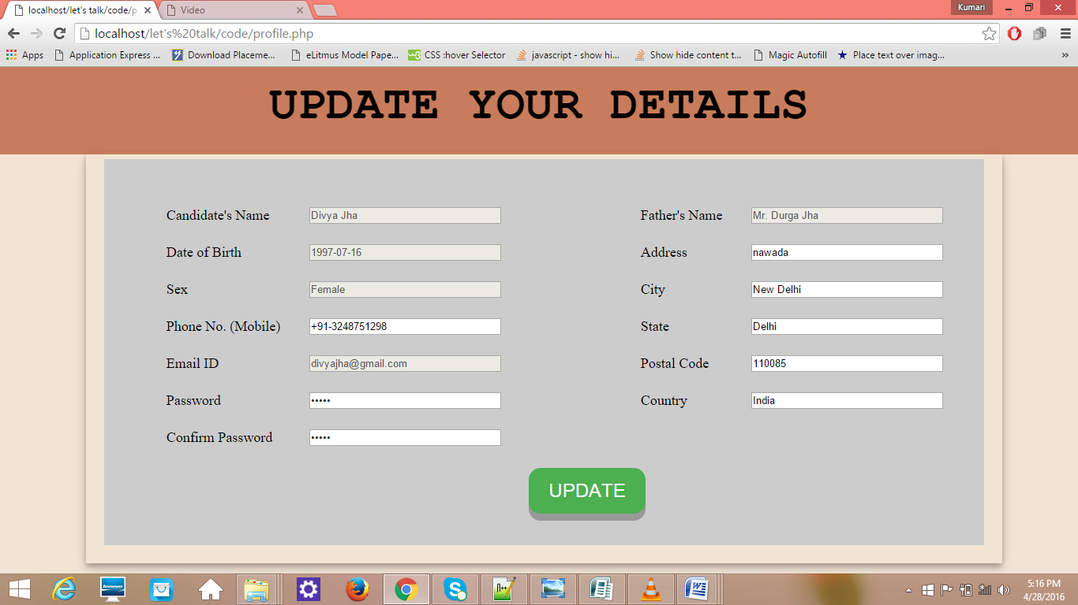

Fig. 4.14: Update personal details

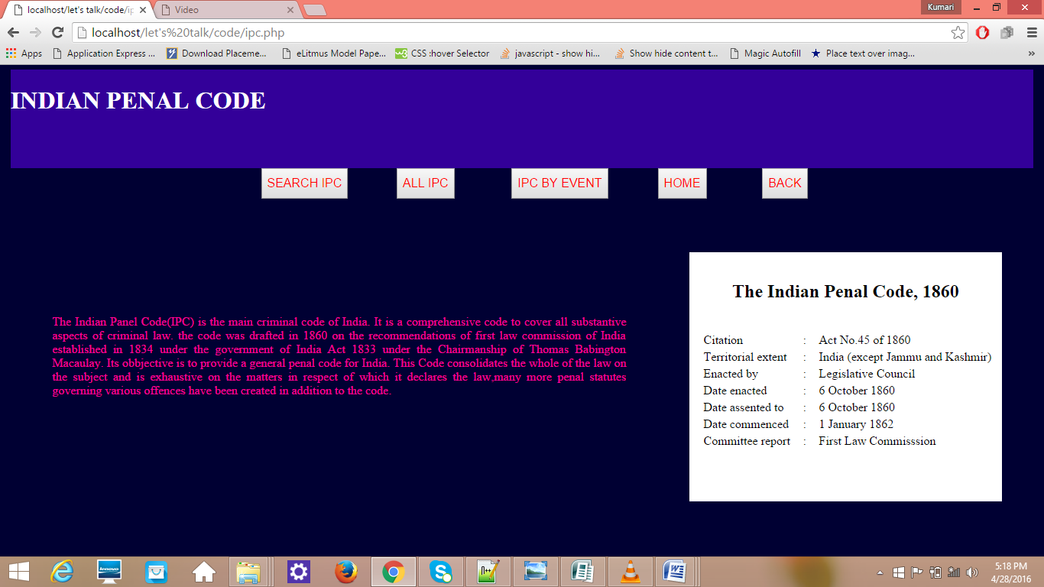

Fig. 4.15: Indian Penal Code

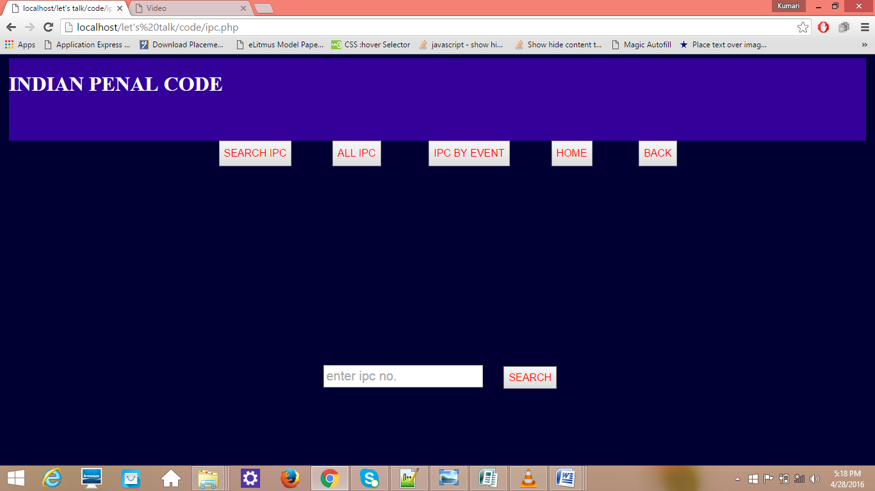

Fig. 4.16: Search IPC number